Лабораторная работа №5

по дисциплине

“Объектно-ориентированное программирование”

Выполнил студент

группы БФИ1901

Гасанов Гамзат

Москва 2020

**Цель:**

Добавить в 4-ую лабораторную работу поддержку нескольких фракталов и реализовать сохранение текущего изображения в файл.

**Код программы:**

public class BurningShip extends FractalGenerator {  
 public static final int *LIMIT* = 2000;  
  
 public void getInitialRange(Rectangle2D.Double range) {  
 range.x = -2;  
 range.y = -2.5;  
 range.width = 4;  
 range.height = 4;  
 }  
  
 public int numIterations(double x, double y) {  
 ComplexNum cmplx = new ComplexNum(0, 0);  
 int iterator = 0;  
  
 while (iterator < *LIMIT* && cmplx.getSquaredModule() < 4) {  
 cmplx.makeSquaredWithAbsInPoint(x, y);  
  
 iterator++;  
 }  
  
 if (iterator == *LIMIT*) return -1;  
  
 return iterator;  
 }  
  
 @Override  
 public String toString() { return "Burning Ship"; }  
}

public class Tricorn extends FractalGenerator {  
 public static final int *LIMIT* = 2000;  
  
 public void getInitialRange(Rectangle2D.Double range) {  
 range.x = -2;  
 range.y = -2;  
 range.width = 4;  
 range.height = 4;  
 }  
  
 public int numIterations(double x, double y) {  
 ComplexNum cmplx = new ComplexNum(0, 0);  
 int iterator = 0;  
  
 while (iterator < *LIMIT* && cmplx.getSquaredModule() < 4) {  
 cmplx.makeSquaredWithConjInPoint(x, y);  
  
 iterator++;  
 }  
  
 if (iterator == *LIMIT*) return -1;  
  
 return iterator;  
 }  
  
 @Override  
 public String toString() { return "Tricorn"; }  
}

public class ComplexNum {  
 public double rl;  
 public double im;  
  
 public ComplexNum(double rl, double im){  
 this.rl = rl;  
 this.im = im;  
 }  
  
 public double getSquaredModule() {  
 return (this.rl * this.rl + this.im * this.im);  
 }  
  
 public void makeSquaredInPoint(double x, double y) {  
 double real = (rl * rl) - (im * im) + x;  
 double imagine = 2 * rl * im + y;  
  
 rl = real;  
 im = imagine;  
 }  
  
 public void makeSquaredWithConjInPoint(double x, double y) {  
 double real = (rl * rl) - (im * im) + x;  
 double imagine = - 2 * rl * im + y;  
  
 rl = real;  
 im = imagine;  
 }  
  
 public void makeSquaredWithAbsInPoint(double x, double y) {  
 double real = (rl * rl) - (im * im) + x;  
 double imagine = 2 * Math.*abs*(rl) * Math.*abs*(im) + y;  
  
 rl = real;  
 im = imagine;  
 }  
}

public class FractalExplorer {  
 private int displaySize;  
 private JImageDisplay display;  
 private FractalGenerator fractal;  
 private Rectangle2D.Double range;  
  
 public FractalExplorer(int size) {  
 displaySize = size;  
  
 fractal = new Mandelbrot();  
 range = new Rectangle2D.Double();  
  
 fractal.getInitialRange(range);  
 display = new JImageDisplay(displaySize, displaySize);  
 }  
  
 public void createAndShowGUI() {  
 display.setLayout(new BorderLayout());  
  
 JButton resetButton = new JButton("Reset");  
 Resetter resetHandler = new Resetter();  
 resetButton.addActionListener(resetHandler);  
  
 JButton saveButton = new JButton("Save");  
 Saver saveHandler = new Saver();  
 saveButton.addActionListener(saveHandler);  
  
 Clicker click = new Clicker();  
 display.addMouseListener(click);  
  
 FractalGenerator mandelbrotFractal = new Mandelbrot();  
 FractalGenerator tricornFractal = new Tricorn();  
 FractalGenerator burningShipFractal = new BurningShip();  
  
 JComboBox comboBox = new JComboBox();  
  
 comboBox.addItem(mandelbrotFractal);  
 comboBox.addItem(tricornFractal);  
 comboBox.addItem(burningShipFractal);  
  
 Chooser fractalChooser = new Chooser();  
 comboBox.addActionListener(fractalChooser);  
  
 JLabel label = new JLabel("Fractal:");  
  
 JPanel panel = new JPanel();  
 panel.add(label);  
 panel.add(comboBox);  
  
 JPanel myBottomPanel = new JPanel();  
 myBottomPanel.add(saveButton);  
 myBottomPanel.add(resetButton);  
  
 JFrame myFrame = new JFrame("Fractal Explorer");  
  
 myFrame.setDefaultCloseOperation(JFrame.*EXIT_ON_CLOSE*);  
 myFrame.add(myBottomPanel, BorderLayout.*SOUTH*);  
 myFrame.add(display, BorderLayout.*CENTER*);  
 myFrame.add(panel, BorderLayout.*NORTH*);  
  
 myFrame.pack();  
 myFrame.setVisible(true);  
 myFrame.setResizable(false);  
 }  
  
 private void drawFractal() {  
 for (int x = 0; x < displaySize; x++) {  
 for (int y = 0; y < displaySize; y++) {  
  
 double xCoord = FractalGenerator.*getCoord*(range.x,  
 range.x + range.width, displaySize, x);  
  
 double yCoord = FractalGenerator.*getCoord*(range.y,  
 range.y + range.height, displaySize, y);  
  
 int iteration = fractal.numIterations(xCoord, yCoord);  
  
 if (iteration == -1) {  
 display.drawPixel(x, y, 0);  
 } else {  
 float hue = 0.5f + (float) iteration / 50;  
 int rgbColor = Color.*HSBtoRGB*(hue, 1f, 1f);  
  
 display.drawPixel(x, y, rgbColor);  
 }  
  
 }  
 }  
 display.repaint();  
 }  
  
 private class Resetter implements ActionListener {  
 public void actionPerformed(ActionEvent e) {  
 if (e.getActionCommand().equals("Reset")) {  
 fractal.getInitialRange(range);  
 drawFractal();  
 }  
 }  
 }  
  
 private class Chooser implements ActionListener {  
 public void actionPerformed(ActionEvent e) {  
 Object source = e.getSource();  
 if (source instanceof JComboBox) {  
 JComboBox comboBox = (JComboBox) source;  
  
 fractal = (FractalGenerator) comboBox.getSelectedItem();  
 assert fractal != null;  
  
 fractal.getInitialRange(range);  
 drawFractal();  
 }  
 }  
 }  
  
 private class Saver implements ActionListener {  
 public void actionPerformed(ActionEvent e) {  
 if (e.getActionCommand().equals("Save")) {  
 JFileChooser fileChooser = new JFileChooser();  
  
 FileFilter extensionFilter = new FileNameExtensionFilter(  
 "PNG",  
 "png"  
 );  
  
 fileChooser.setFileFilter(extensionFilter);  
  
 fileChooser.setAcceptAllFileFilterUsed(false);  
  
 int userSelection = fileChooser.showSaveDialog(display);  
  
 if (userSelection == JFileChooser.*APPROVE_OPTION*) {  
 java.io.File file = fileChooser.getSelectedFile();  
 String filePath = file.getPath();  
  
 if (!filePath.contains(".png")) file = new File(filePath + ".png");  
 try {  
 BufferedImage displayImage = display.getImage();  
 javax.imageio.ImageIO.*write*(displayImage, "png", file);  
 } catch (Exception exception) {  
 JOptionPane.*showMessageDialog*(display,  
 exception.getMessage(), "Cannot Save Image",  
 JOptionPane.*ERROR_MESSAGE*);  
 }  
 }  
 else return;  
 }  
 }  
 }  
  
 private class Clicker extends MouseAdapter {  
 @Override  
 public void mouseClicked(MouseEvent e) {  
 int x = e.getX();  
 double xCoord = FractalGenerator.*getCoord*(range.x,  
 range.x + range.width, displaySize, x);  
  
 int y = e.getY();  
 double yCoord = FractalGenerator.*getCoord*(range.y,  
 range.y + range.height, displaySize, y);  
  
 fractal.recenterAndZoomRange(range, xCoord, yCoord, 0.5);  
  
 drawFractal();  
 }  
 }  
  
 public static void main(String[] args)  
 {  
 FractalExplorer displayExplorer = new FractalExplorer(800);  
 displayExplorer.createAndShowGUI();  
 displayExplorer.drawFractal();  
 }  
}

**Примеры работы программы:**

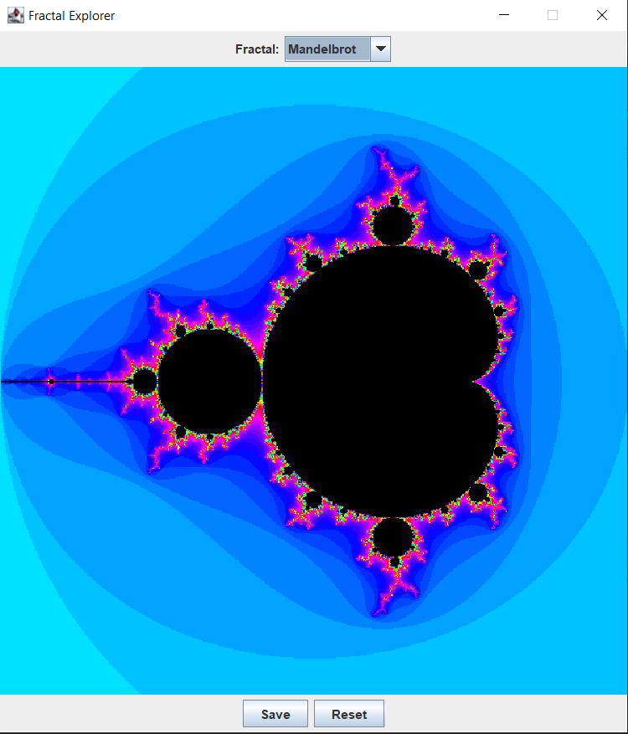

Рисунок 1 - Вывод фрактала Мандельброта

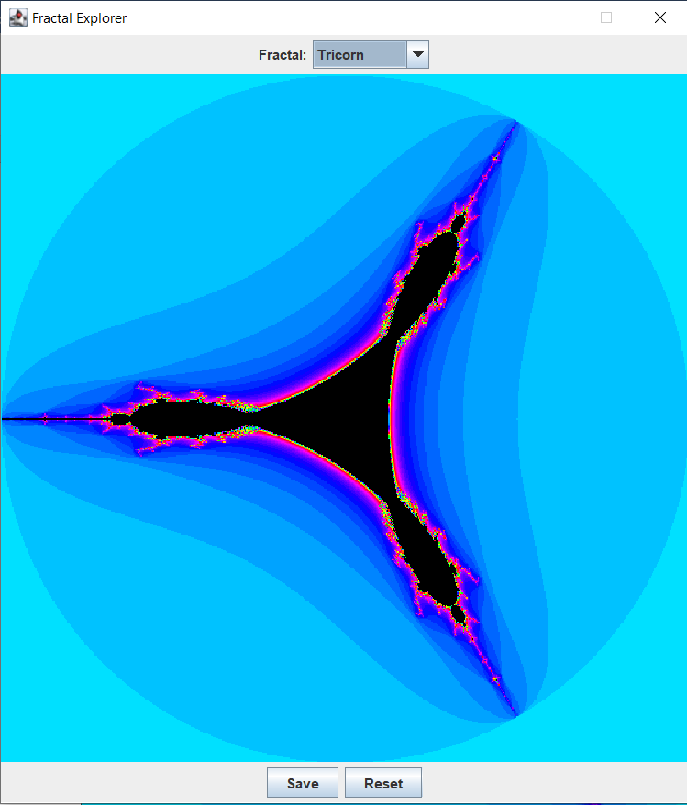

Рисунок 2 - Вывод фрактала «Трикорн»

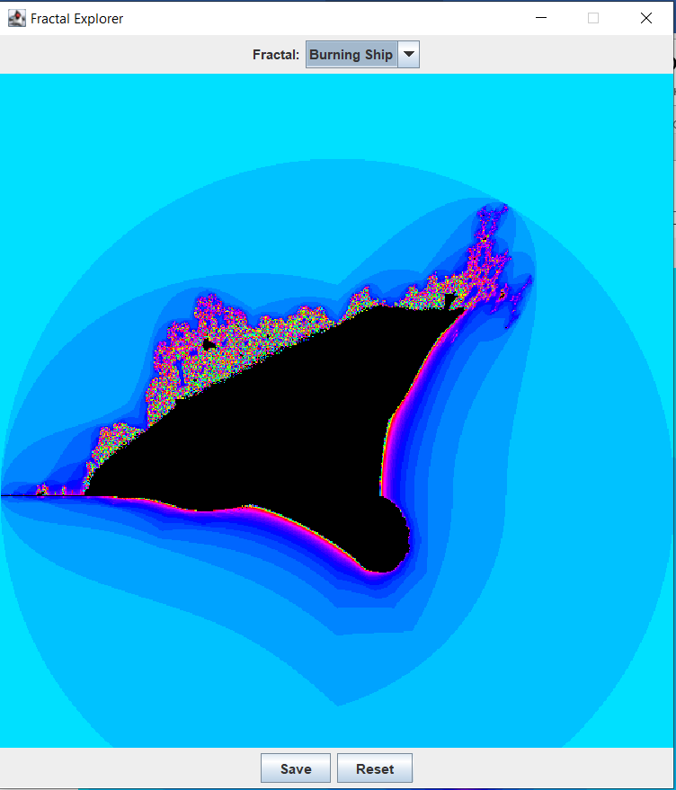

Рисунок 3 - Вывод фрактала Пылающий корабль

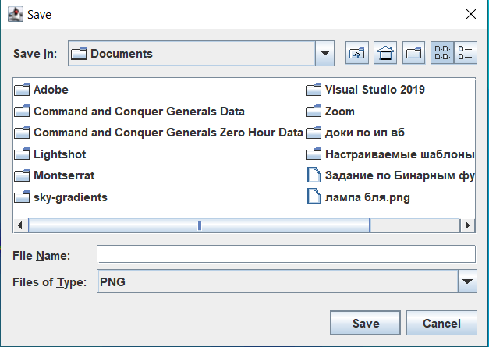

Рисунок 4 – Окно сохранения